**ASSIGNMENT-2**

**DATA MODULE:**

**LINK:**

<https://us3.ca.analytics.ibm.com/bi/?perspective=ca-modeller&pathRef=.my_folders%2FHR%2Bdatamodule>

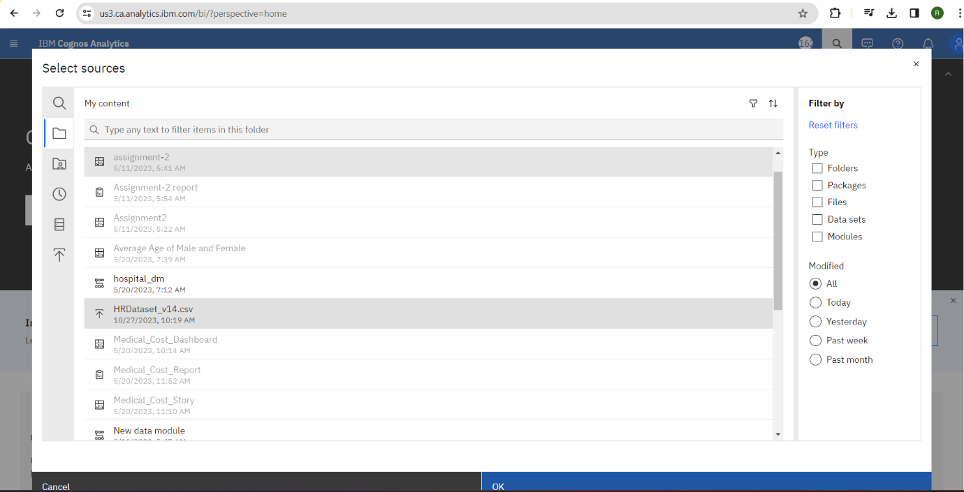

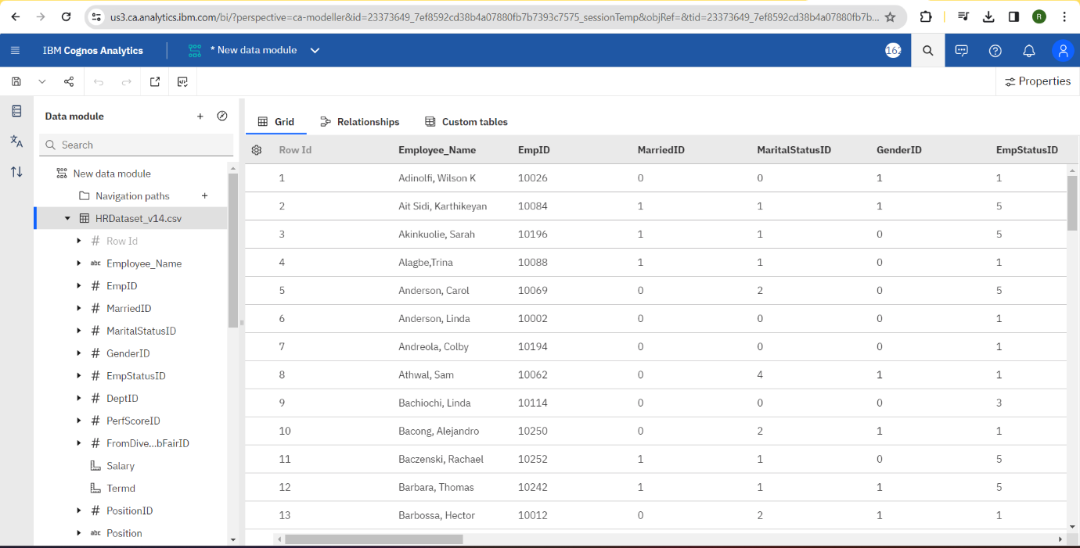

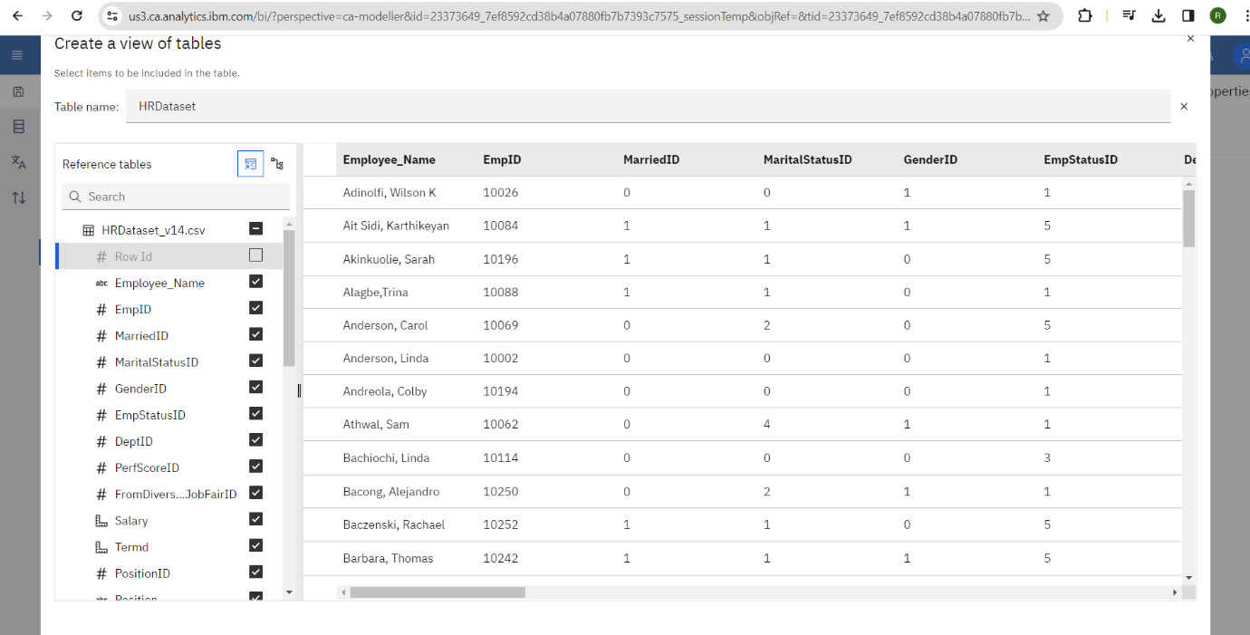

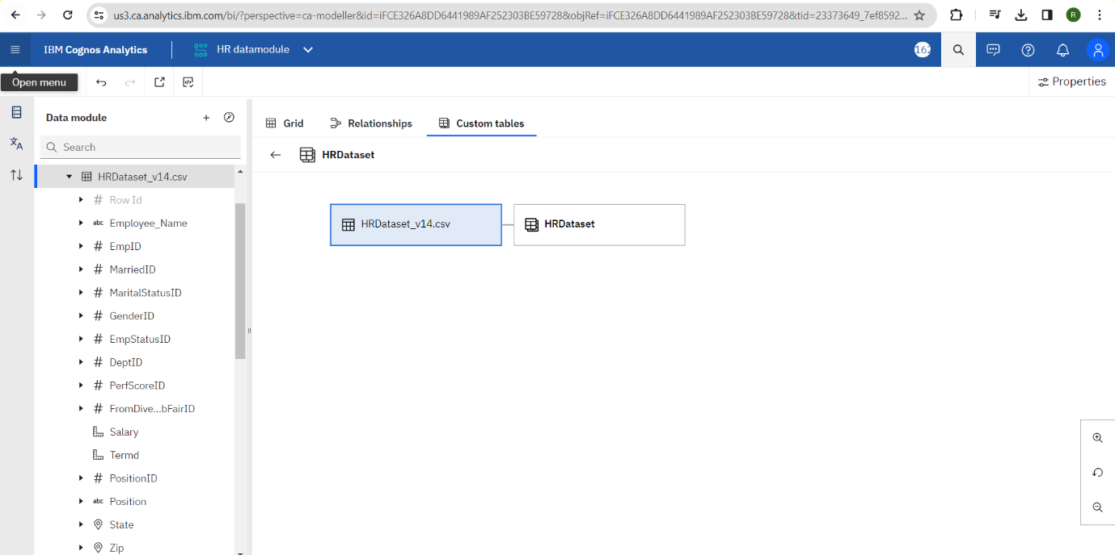

**EXPLORATION:**

**LINK:**

<https://us3.ca.analytics.ibm.com/bi/?perspective=explore&pathRef=.my_folders%2FHR%2Bexploration&subView=model0000018b71c7feb0_00000004>

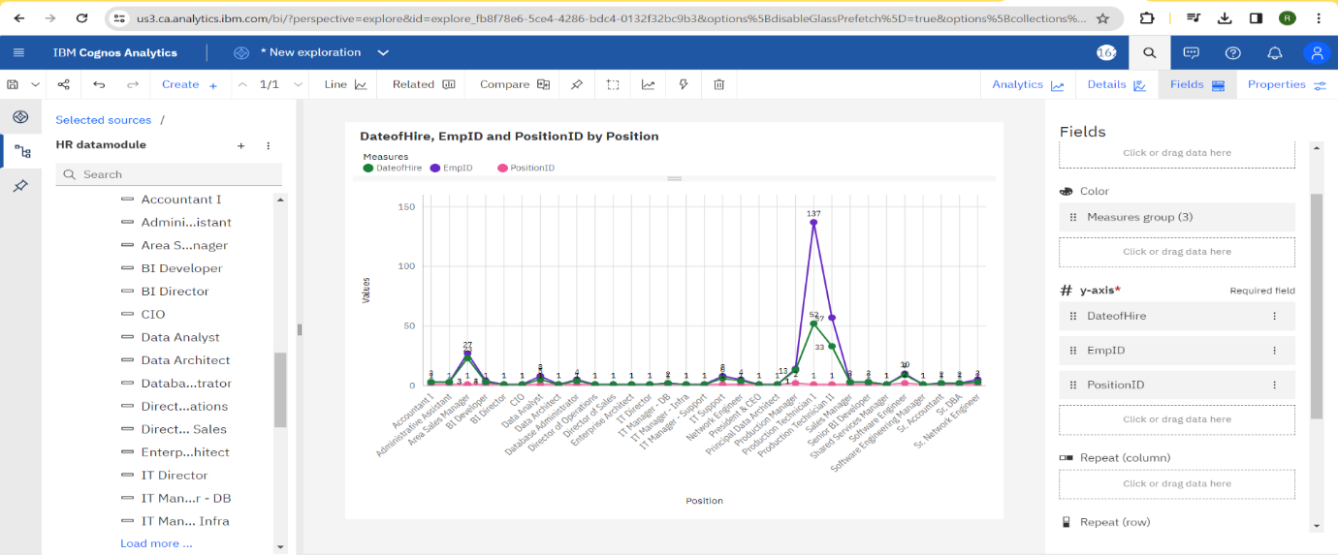

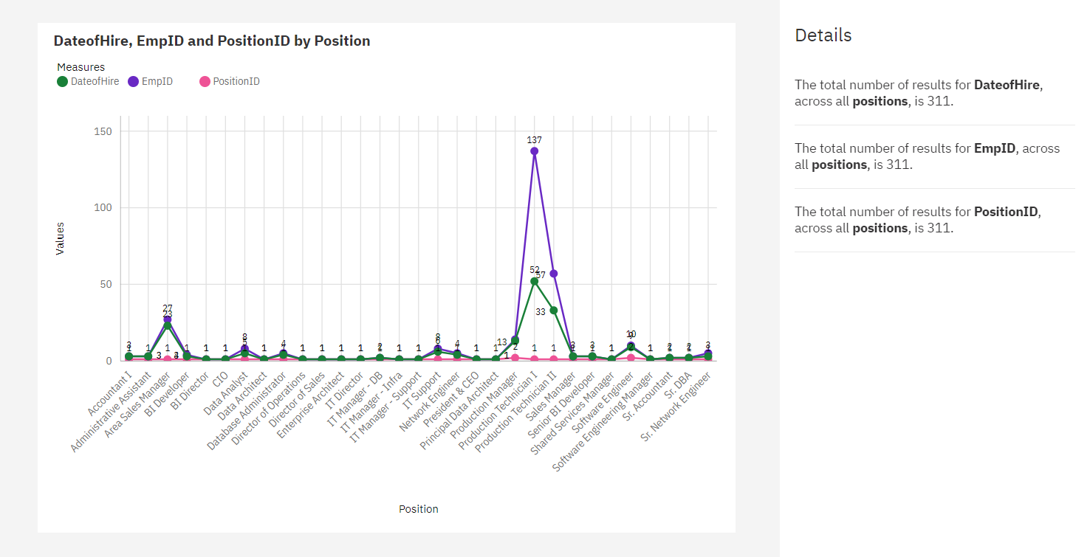

**LINK:**

<https://us3.ca.analytics.ibm.com/bi/?perspective=explore&pathRef=.my_folders%2FHR%2Bexploration&subView=model0000018b71de6c38_00000000>

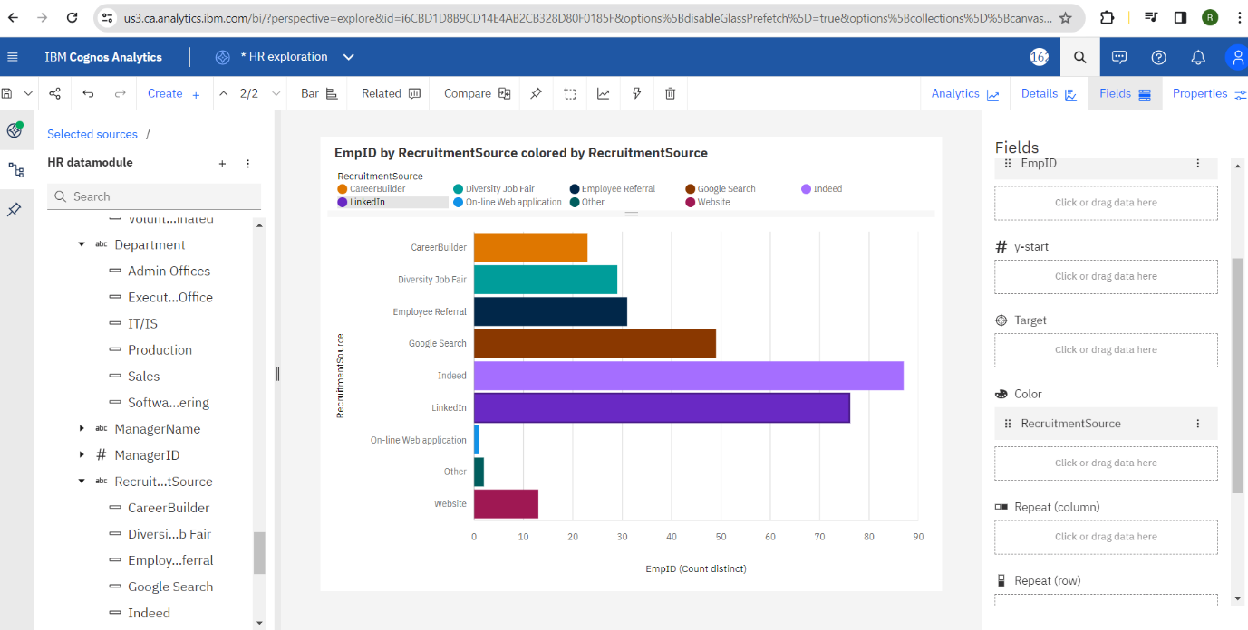

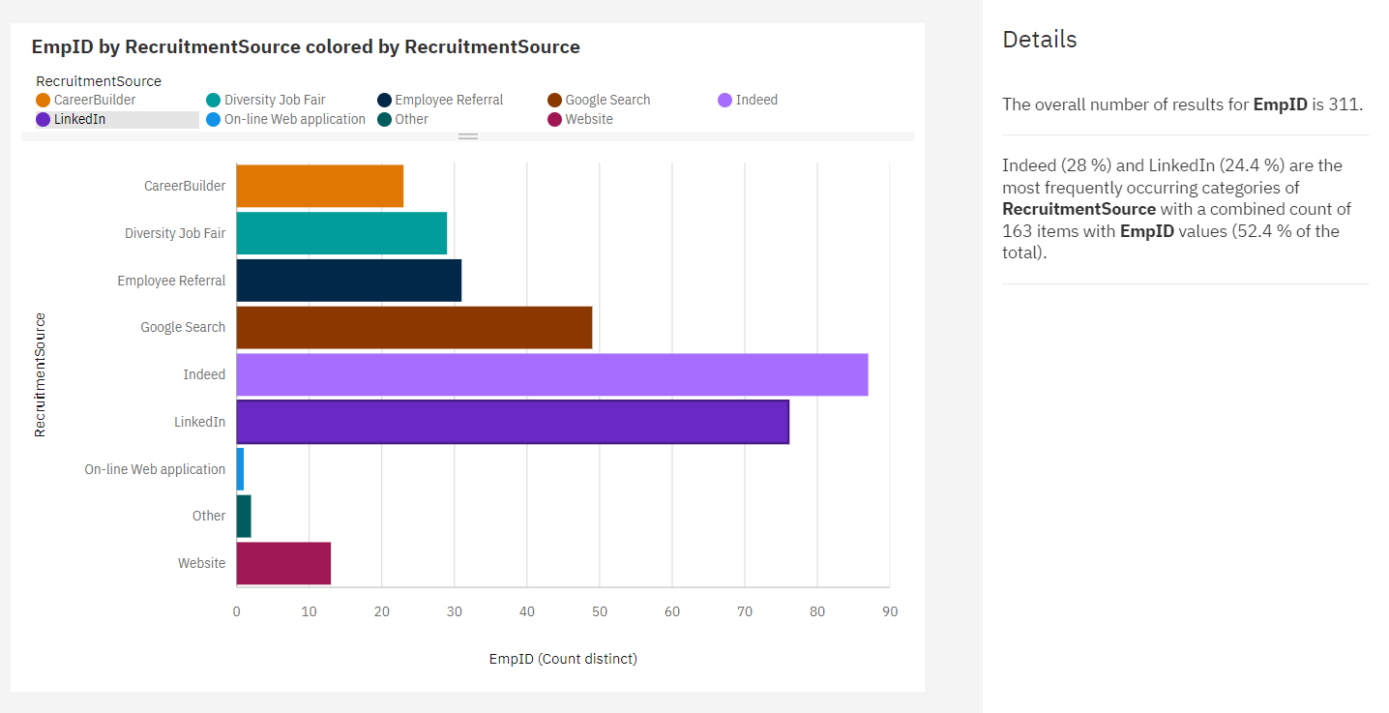

**LINK:**

<https://us3.ca.analytics.ibm.com/bi/?perspective=explore&pathRef=.my_folders%2FHR%2Bexploration&subView=model0000018b721ba495_00000004>

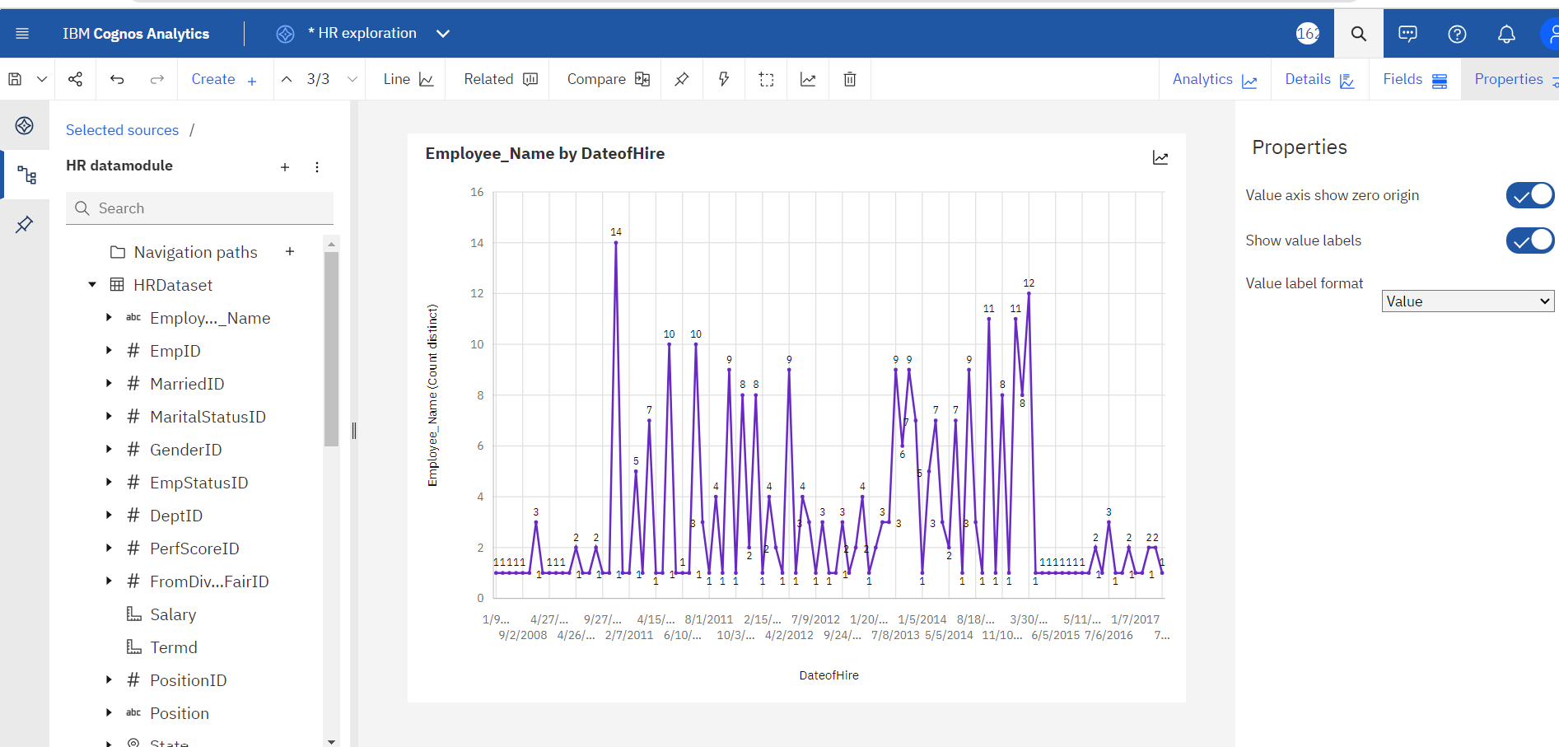

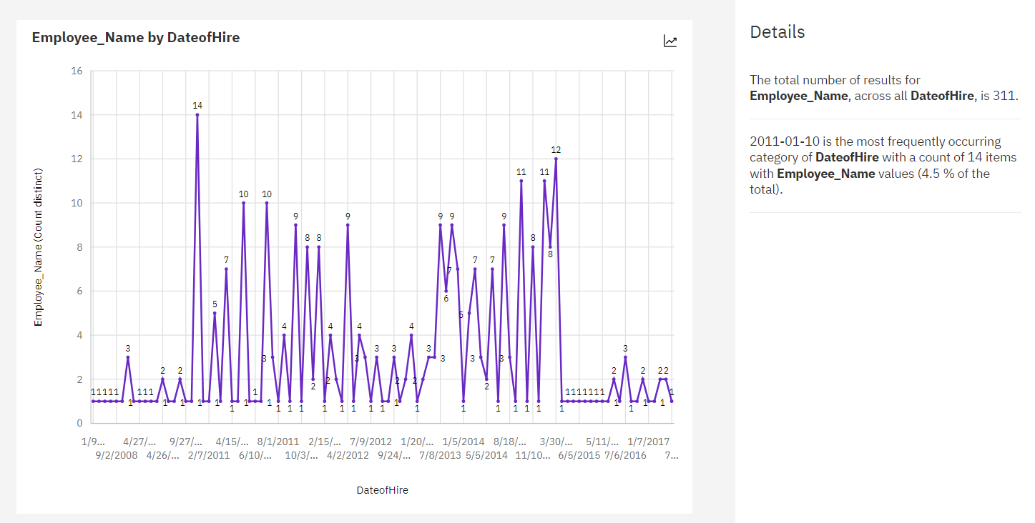

**LINK:**

<https://us3.ca.analytics.ibm.com/bi/?perspective=explore&pathRef=.my_folders%2FHR%2Bexploration&subView=model0000018b7225b47d_00000004>

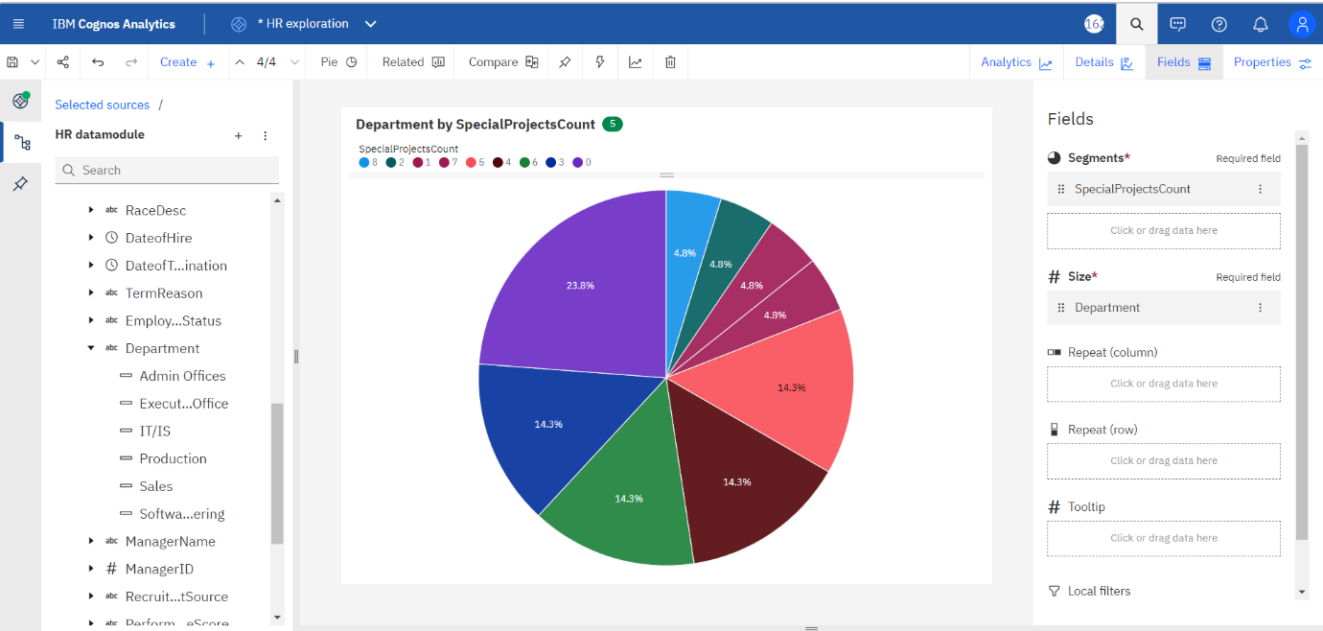

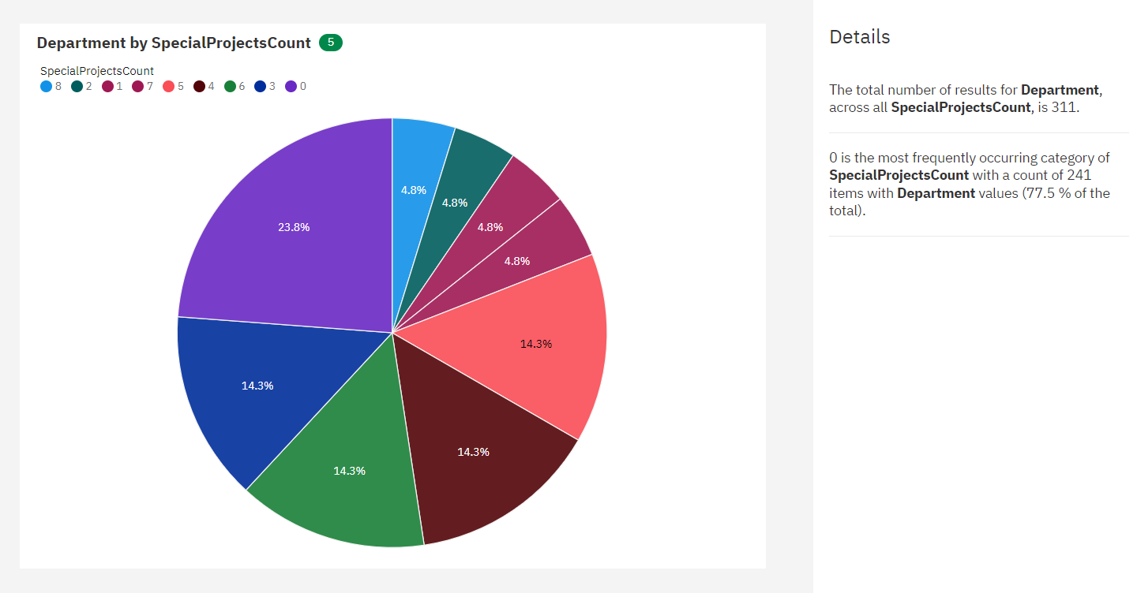

**LINK:**

<https://us3.ca.analytics.ibm.com/bi/?perspective=explore&pathRef=.my_folders%2FHR%2Bexploration&subView=model0000018b722bfe33_00000000>

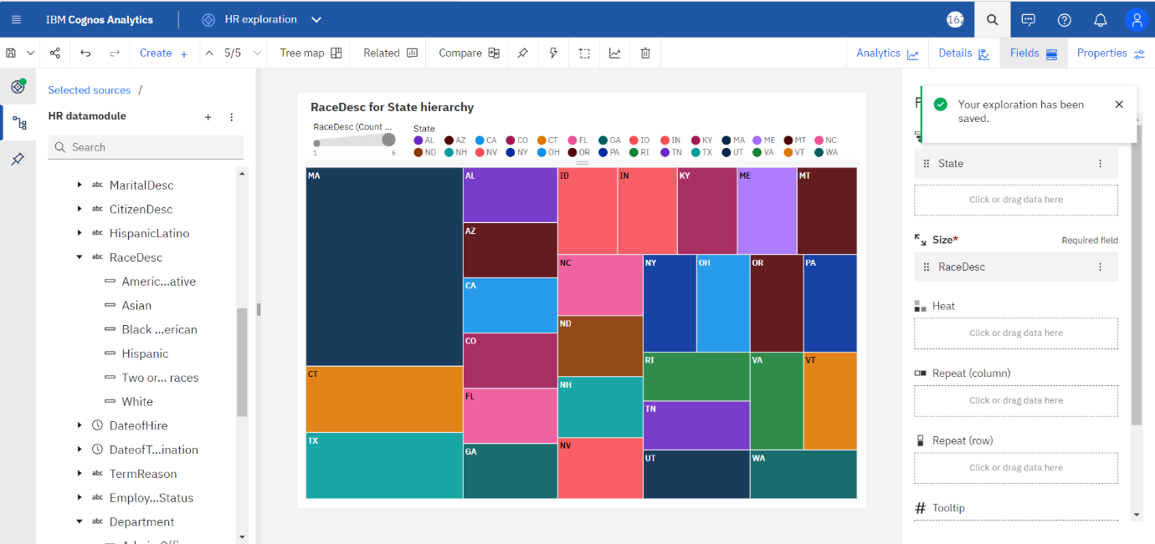

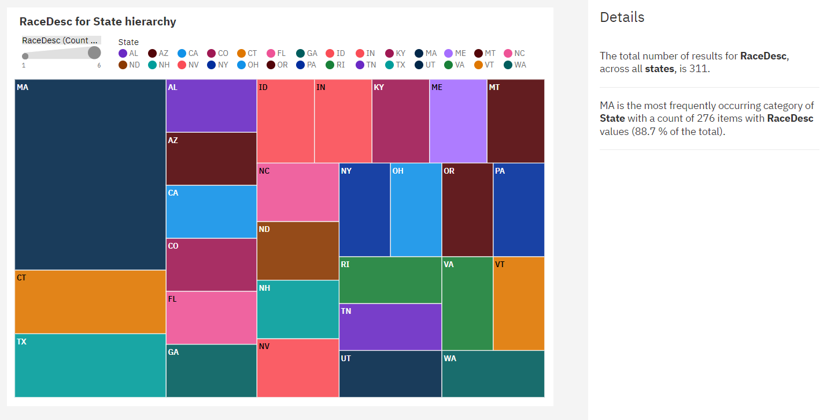

**LINK:**

<https://us3.ca.analytics.ibm.com/bi/?perspective=explore&pathRef=.my_folders%2FHR%2Bexploration&subView=model0000018b723aa0a1_00000005>

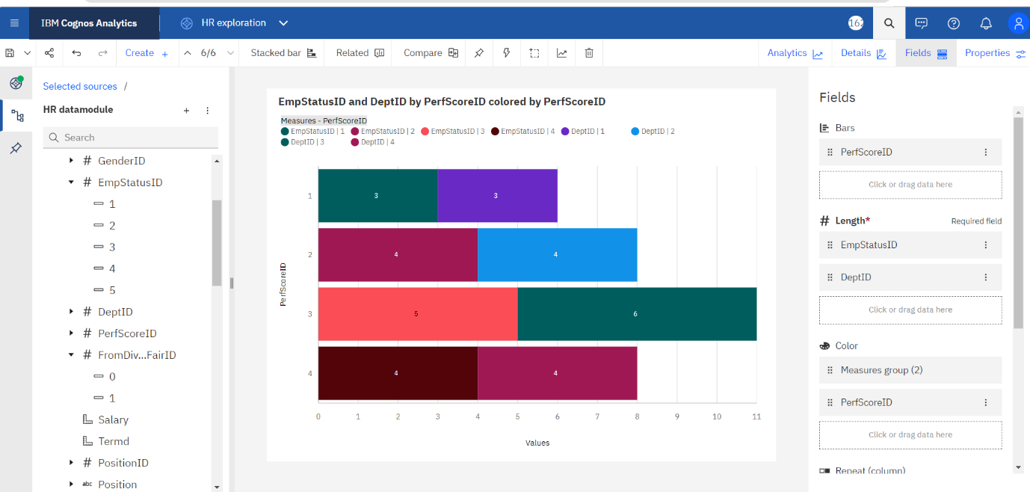

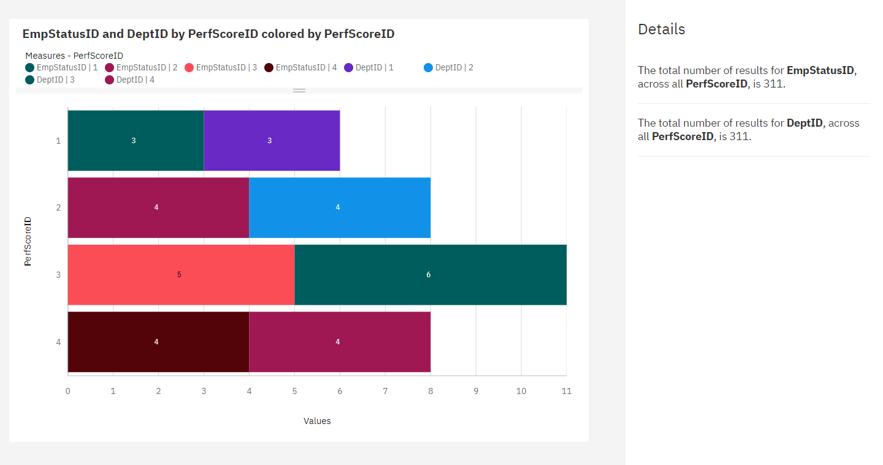

**LINK:**

<https://us3.ca.analytics.ibm.com/bi/?perspective=explore&pathRef=.my_folders%2FHR%2Bexploration&subView=model0000018b723ca141_00000004>

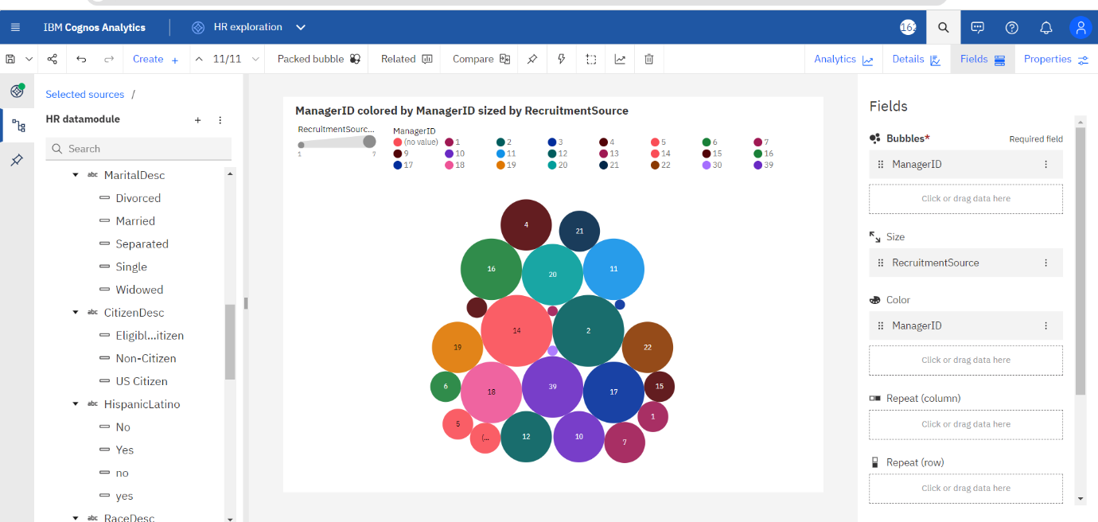

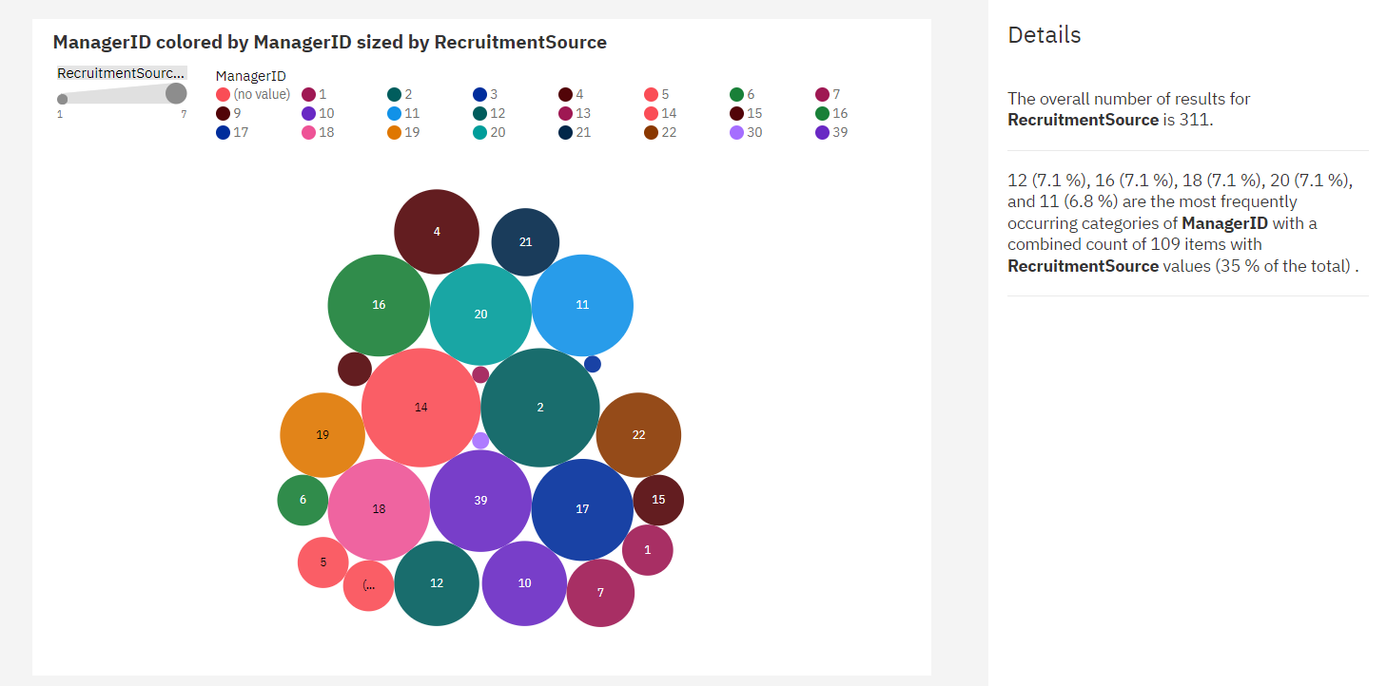

**LINK:**

<https://us3.ca.analytics.ibm.com/bi/?perspective=explore&pathRef=.my_folders%2FHR%2Bexploration&subView=model0000018b724a88ef_00000000>

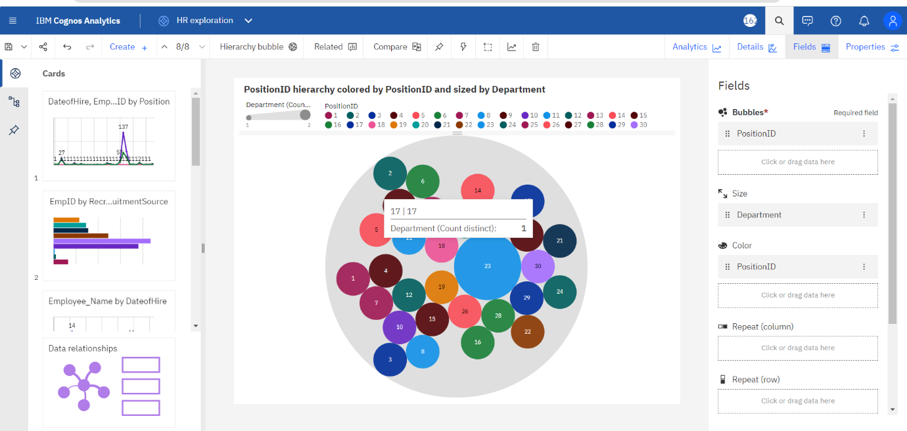

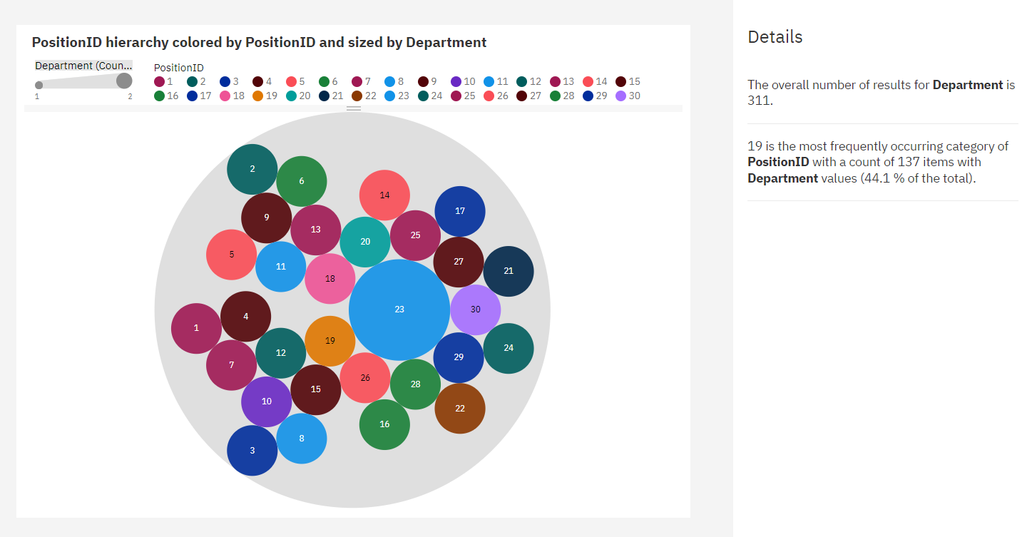

**LINK:**

<https://us3.ca.analytics.ibm.com/bi/?perspective=explore&pathRef=.my_folders%2FHR%2Bexploration&subView=model0000018b72589015_00000004>

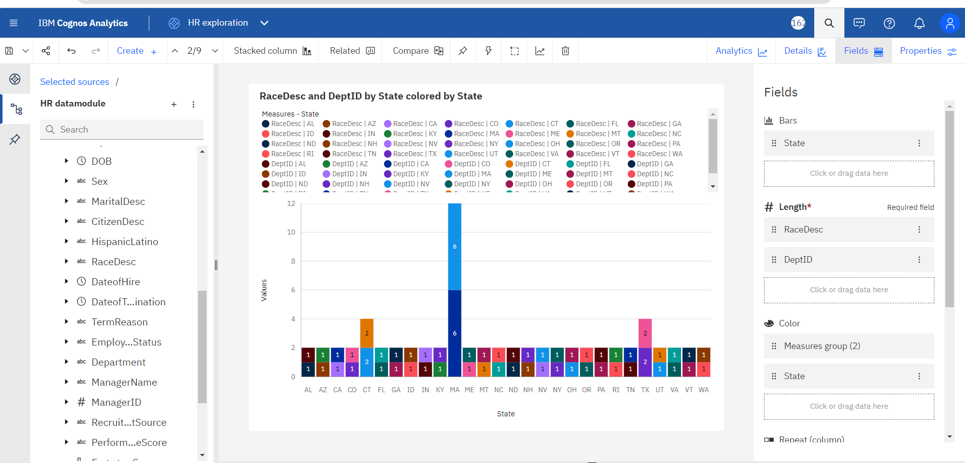

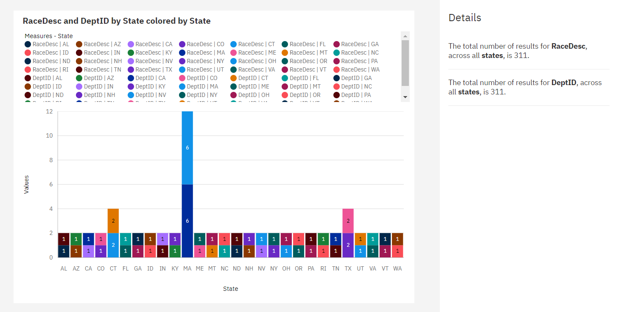

**DASHBOARD:**

**LINK:**

<https://us3.ca.analytics.ibm.com/bi/?perspective=dashboard&pathRef=.my_folders%2FHR%2Bdashboard&action=view&mode=dashboard&subView=model0000018b79c8907e_00000000>

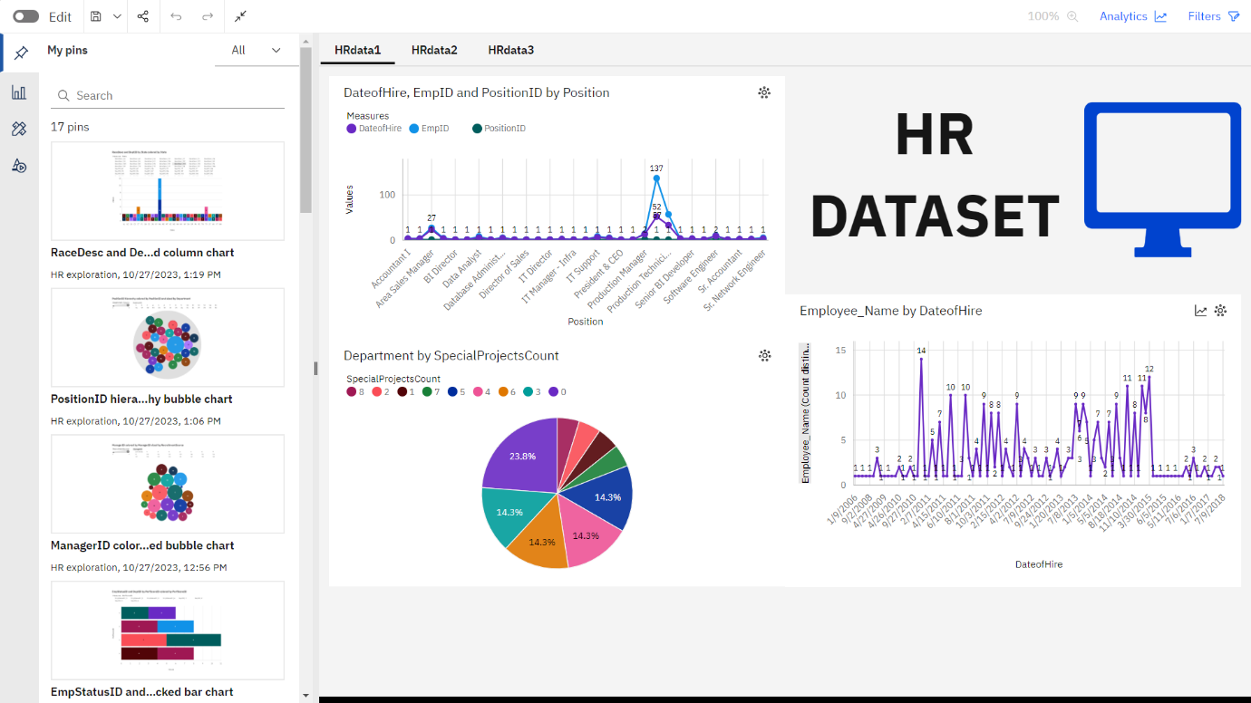

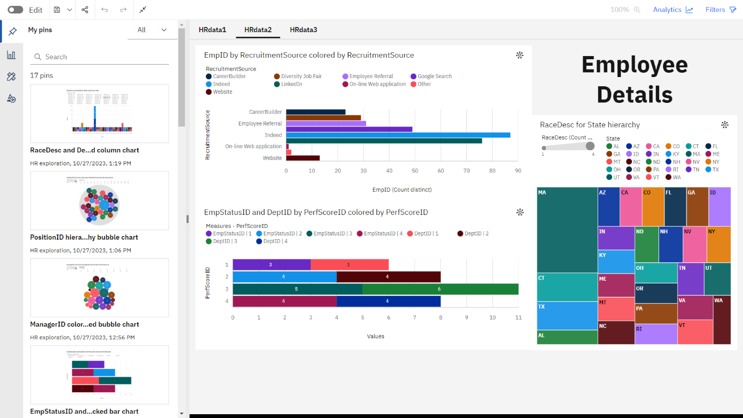

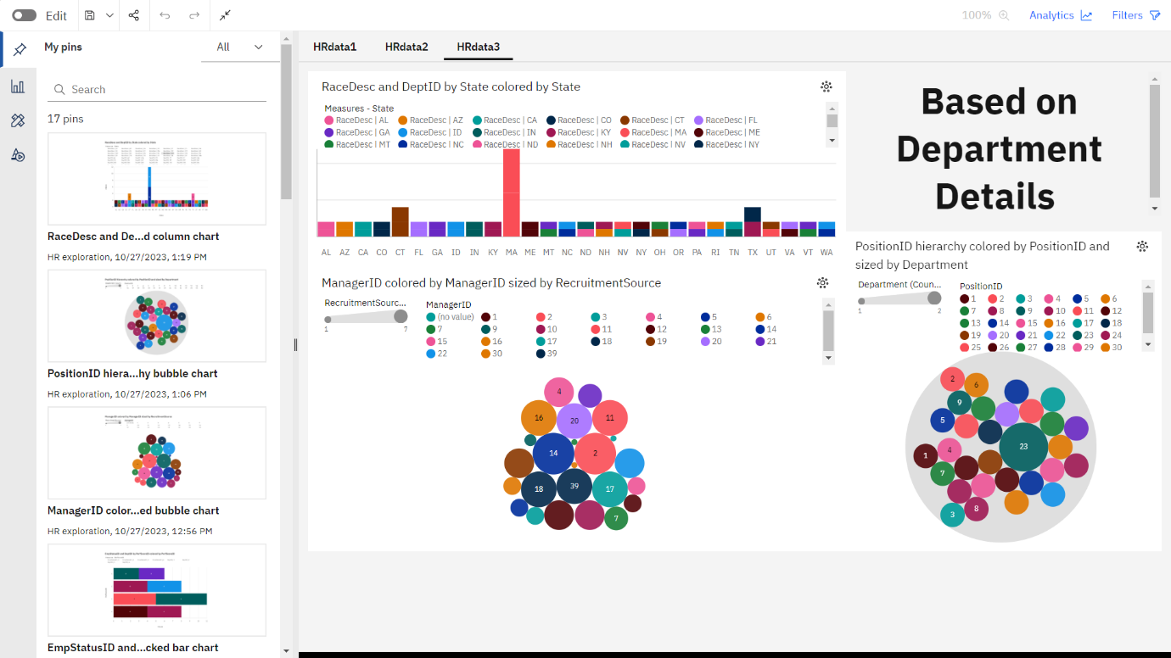

**REPORT:**

**LINK:**

<https://us3.ca.analytics.ibm.com/bi/?pathRef=.my_folders%2FHR%2Breport&action=run&format=HTML&prompt=false>

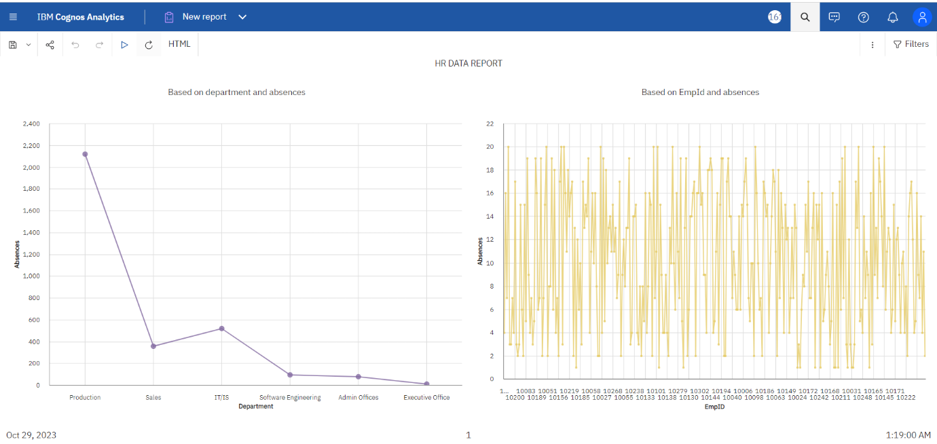

**STORY:**

**LINK:**

<https://us3.ca.analytics.ibm.com/bi/?perspective=story&pathRef=.my_folders%2FHR%2Bstory&action=view&sceneId=model0000018b7a19feee_00000003&sceneTime=5000>

